Design patterns Course: Exercise 1

**Facebook basic experience:**

The user can view his profile pictures and slide through his profile pictures album.

**Facebook Feature 1:**

Shows the inactive liked pages so the user can know which pages to unlike.

The user can choose the number of days that will determine if a page is inactive.

# Feature 1: Sequence Diagram

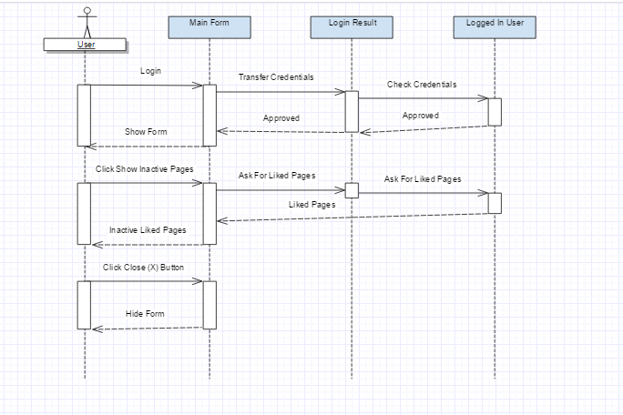

**Facebook Feature 2:**

The Feature gives the user basic image editing tools to edit photos either from facebook’s profile picture or from his local computer, and publish the edited photo to Facebook with a custom Post Title.

The User may also create custom image filters and save them for future usage.

(The default Privacy settings for the new uploaded post is “Only-Me”).

# Feature 2: Sequence Diagram



# Use Case Diagram

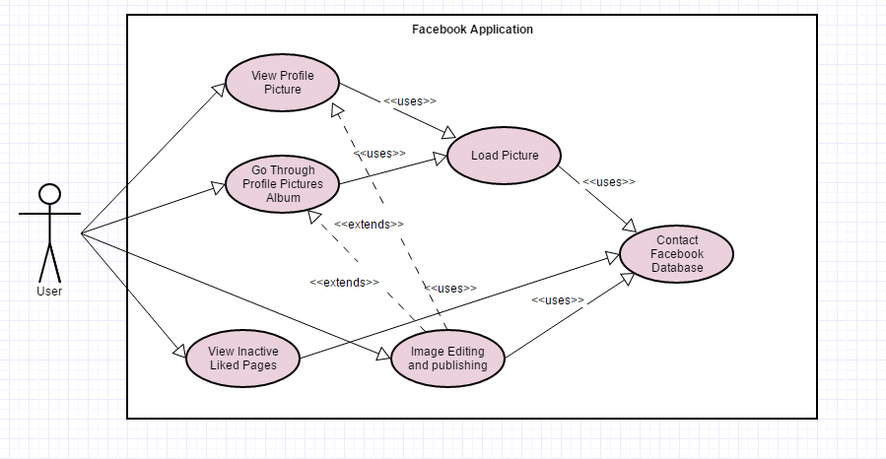

# Class Diagram

